Paper Title*
First Author name¹, Second Author Full ,*,and Third Author Full name
¹Department, Name of Organization (of Affiliation), University Name, City, Country, Postcode; email address
²Department, Name of Organization (of Affiliation), University Name, City, Country, Postcode; email address
³Department, Name of Organization (of Affiliation), University Name, City, Country, Postcode; email address

*Corresponding Author: author@gmail.com
Date of Submission: Date of Revision: Date of Acceptance: Date of Publication:

Abstract - This electronic document is a “live” template and already defines the components of your paper [title, text, heads, etc.] in its style sheet. *CRITICAL: Do Not Use Symbols, Special Characters, Footnotes, or Math in Paper Title or Abstract.
Keywords— Table, figure, component, formatting, style, styling, insert (key words)

1. Introduction (Heading 1)
This template, modified in MS Word 2007 and saved as a “Word 97-2003 Document” for the PC, provides authors with most of the formatting specifications needed for preparing electronic versions of their papers. The Manuscript length should contain 5 pages at least. In general, a full manuscript consists of "Introduction", "Objectives", "Methods", "Results", "Discussion" and "Conclusions". English is treated as the only written language throughout the text. Margins, column widths, line spacing, and type styles are built-in; examples of the type styles are provided throughout this document and are identified in italic type, within parentheses, following the example. Some components, such as multi-leveled equations, graphics, and tables are not prescribed, although the various table text styles are provided.

2. Ease of Use

2.1 Selecting a Template (Heading 2)
First, confirm that you have the correct template for your paper size. This template has been tailored for output on the A4 paper size. If you are using US letter-sized paper, please close this file and download the Microsoft Word, Letter file.

2.2 Maintaining the Integrity of the Specifications
The template is used to format your paper and style the text. All margins, column widths, line spaces, and text fonts are prescribed; please do not alter them. You may note peculiarities. For example, the head margin in this template measures proportionately more than is customary. This measurement and others are deliberate, using specifications that anticipate your paper as one part of the entire proceedings, and not as an independent document. Please do not revise any of the current designations.

3. Materials and Methods
Present the research design, research type, research duration, inclusion/exclusion criteria, choice of subjects, etc. Describe the methodology completely, including sample collection, processing, lab analysis, statistical tests used for data analysis etc. Use section headings/subheadings in a logical order to entitle each category or method. A maximum of three levels of headings may be used. Usually, headings are numbered with Arabic numerals (1., 2.; 1.1., 1.2.; 1.1.1., 1.2.1….). It’s preferred to illustrate with tables and figures.

3.1. Paper Title
A paper should have a short, straightforward title directed at general readers in no more than 20 words.

3.2. Authors & Affiliations
List the first and last names of all authors. Provide the full affiliation for each author including Department, University, City, State, Country. If any of the co-authors are from different organizations, their affiliation should be numbered with different Arabic numerals. Email address is compulsory for the corresponding author.
e.g., Josh Jacobus¹, Garrett Elleithy², Jamal Ghaly³
¹College of Engineering, Boston University, Boston, Massachusetts, United States
²Chemical Engineering Faculty, California Institute of Technology, Pasadena, California, United States
³College of Arts and Sciences, University of Pennsylvania, Philadelphia, Pennsylvania, United States

3.3. Abstract & Keywords
The abstract should concisely state the purpose of the investigation and summarize the important conclusions. It should be a single paragraph of generally no more than 200 words.
Immediately after the abstract, 3-8 words or short phrases should be included for online searching (e.g., Keywords Table, Figure, Manuscript Format)

3.4. Figures & Tables

3.4.1Positioning Figures and Tables

Place figures and tables at the top and bottom of columns. Avoid placing them in the middle of columns. Large figures and tables may span across both columns. Figure captions should be below the figures; table heads should appear above the tables. Insert figures and tables after they are cited in the text. Use the abbreviation “Fig. 1”, even at the beginning of a sentence.
Table 1 : Example of a figure caption. (figure caption)

Table Head | Table Column Head
Table Head | Table column subhead | Subhead | Subhead
copy | More table copy

Figure Labels: Use 8 point Times New Roman for Figure labels. Use words rather than symbols or abbreviations when writing Figure axis labels to avoid confusing the reader. As an example, write the quantity “Magnetization”, or “Magnetization, M”, not just “M”. If including units in the label, present them within parentheses. Do not label axes only with units. In the example, write “Magnetization (A/m)” or “Magnetization {A[m(1)]}”, not just “A/m”. Do not label axes with a ratio of quantities and units. For example, write “Temperature (K)”, not “Temperature/K”.

3.4.2. Figures Caption
Each figure should have a caption. The caption should be concise and typed separately, not on the figure area; If figures have parts (for example, A and B), make sure all parts are explained in the caption.

1. PartAad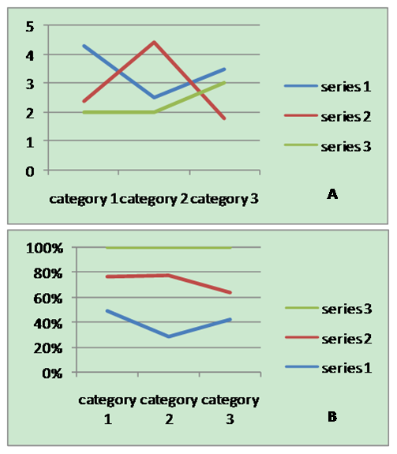
Figure 1. Part A and Part B

3.4.3. Figures, Numbering & Citation
All figures are to be sequentially numbered with Arabic numerals. Figures should always be cited in consecutive numerical order. (Figure 1) Parts in a figure can be identified by A, B, C etc. and cited as Fig. 2A, Fig. 2B, Fig. 2C. For larger figures or tables (8.4cm ≤Width ≤17cm), you may put them in one column. (Figure 3 & Table 1)

3.4.4. Figures Resolution
Figures must be created at a minimum resolution of 300 dpi to avoid bad printing quality. For fuzzy or jagged figures, authors are required to replace it or send the original figure file to us for reproduction.

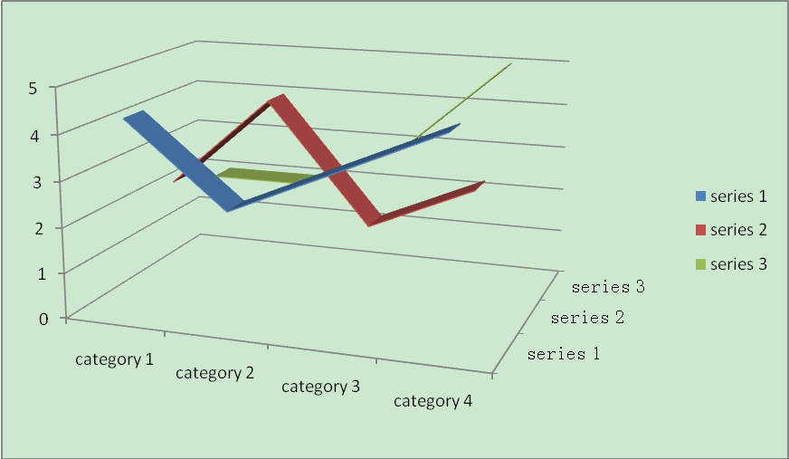
Figure 2. A large figure in one column

Table 2. Specific data of Column/Row

 | Column Header 1 | Column Header 2
Row Header 1 | X | X
Row Header 2 | X | X

3.5. Tables

3.5.1. Tables Title
Every table must have a unique title placed at the top. Titles should be clear and concise, and they should not be complete sentences.

3.5.2. Tables Format
Table tools in Microsoft Word are recommended for inserting a table. It’s necessary to avoid tables created with the tab key.

3.5.3. Tables Numbering & Citation
Tables in the main body of the text should be numbered consecutively according to its appearance in the text. Cite each table in numerical order.

3.6. Equation

3.6.1. Equation Format
The equation number should be placed in parentheses to the right of the equation. Do not create equations as pictures. Use Math Type or insert symbols as normal text.
Equation as normal text:
E=MC² (1)
Equation created by Math Type:
(2)
3.6.2. Equation Numbering & Citation
Equations should be numbered consecutively with Arabic numerals to avoid ambiguities, if they will be referred to in text. Citation for an equation should be made by using “(1),” not “Eq. (1)” or “equation (1),” except at the beginning of a sentence: “Equation (1) is…”

3.7. Appendix
An appendix may be included (and is often helpful) in mathematical or computational modeling.

3.8. Reference Style
All sources cited in text must appear in the reference list, and all items in the reference list must be cited in text. With the numerical system, references are arranged in the reference list so that they match the order in which they are cited in the text.

3.8.1. Reference in-Text Citation Format
References are simply cited with the consistent reference number in square brackets. Do not set references number as superscript number. Do not use “Ref. [3]” or “Reference [3]” except at the beginning of a sentence, e.g. “Reference [3] shows …”
A. Single Reference
If the author's name appears in the text, place the reference number immediately after the name.
E.g., Peter [10] found an innovative scientific phenomenon.
B. Multiple References
1) Put two or four numbers in numerical order and separate them by commas but no spaces.
E.g.: [2,3], [2,3,4]
2) Indicate three or more consecutive reference numbers by giving the first and last numbers separated by a hyphen.
E.g.: [3-5]

3.8.2. List of References

Authors are requested to check all references for completeness, including author names, paper title, publisher, journal heading, Volume, Issue Number., pages for journal citations, Year.

Books

ll author names, Book title, Publisher, Country, Year.
e.g., R. F. Voss, J. Clarke. Biomedical Signal processing, Silver Burdett Press, Londyn, 1986.

Journals

All author names, Title, Publisher, Journal title, Vol, No, pp, Year
e.g., W. Zabierowski, A. Napieralski. Chords classification in tonal music, TBEAH Journal, Vol.10, No.5, 50-53,. 2001

Conference Papers

All author names, Title, Conference title, pp, Year.
e.g., A. Abiewskiro, Z. Moplskiiera. Applications of Biomedical Engineering and healthcare, TCSET of the International Conference, House of Lviv Polytechnic National University, 19-23, 2008.

Websites

Online Available: http:// e.g.: Farquhar C, Clinical Engineering, online available from http://www.tbeah.org

Number

.2

4. Conclusion
Any comments and suggestions are welcomed so that we can constantly improve this template to satisfy all authors’ research needs.

REFERENCESefe
ng, Volume, Issue Number., pages for journal citations, Year.Books
e.g., R. F. Voss, J. Clarke. Bimedical Signal processing, Silver Burdett Press, Londyn, 1986.
All author names, Title, Publisher, Journal title, Vol, No, pp, Year
.10, No.5, 50-53, 2001Conference Papers
e.g., A. Abiewskiro, Z. Moplskiiera. Applications of Biomedical Engineering and healthcare, TCSET of the International Conference, House of Lviv Polytechnic National University, 19-23, 2008.
Online Available: http:// e.g.: Farquhar C, Clinical Engineering, online available from http://www.tbeah.org

- R. F. Voss, J. Clarke. Biomedical Signal processing, Silver Burdett Press, Londyn, 1986.
- W. Zabierowski, A. Napieralski. Bioinformatics, TBEAH Journal, Vol.10, No.5, 50-53., 2001
- A. Abiewskiro,. Z. Moplskiiera. Applications of Biomedical Engineering and healthcare, TCSET of the International Conference, House of Lviv Polytecignalhnic National University, 19-23, 2008.
- Farquhar C, Clinical Engineering, online available from http://www.tbeah.org
- G. Eason, B. Noble, and I. N. Sneddon, “On certain integrals of Lipschitz-Hankel type involving products of Bessel functions,” Phil. Trans. Roy. Soc. London, vol. A247, pp. 529–551, April 1955. (references)
- J. Clerk Maxwell, A Treatise on Electricity and Magnetism, 3rd ed., vol. 2. Oxford: Clarendon, 1892, pp.68–73.
- I. S. Jacobs and C. P. Bean, “Fine particles, thin films and exchange anisotropy,” in Magnetism, vol. III, G. T. Rado and H. Suhl, Eds. New York: Academic, 1963, pp. 271–350.

